**How to Capture Your Console Output**

There are basically 2 techniques to capture your console output.

The first

1. Use the PrtSc key on your keyboard. This key may be used by itself or in conjunction with the Shift, Alt, Ctrl, or Fn keys. You will have to experiment with that as many keyboards are different.
2. This will capture your console and save it to the Windows clipboard.
3. Open up a word processing document.
4. Use Ctrl-V key combination to paste the captured console to the word processing document.
5. Once pasted you are free to scale or crop the image captured as desired

The disadvantage of this is that it is not always the easiest to read and does use a lot more printer ink.

The second option

Given this console

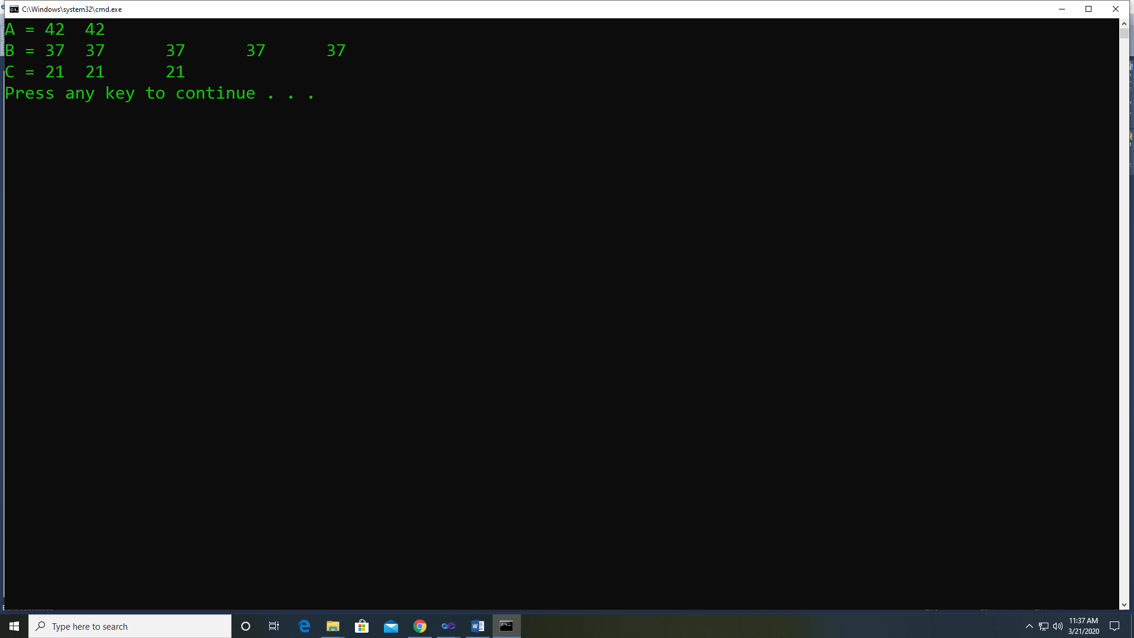

In the upper right corner, there is a menu available

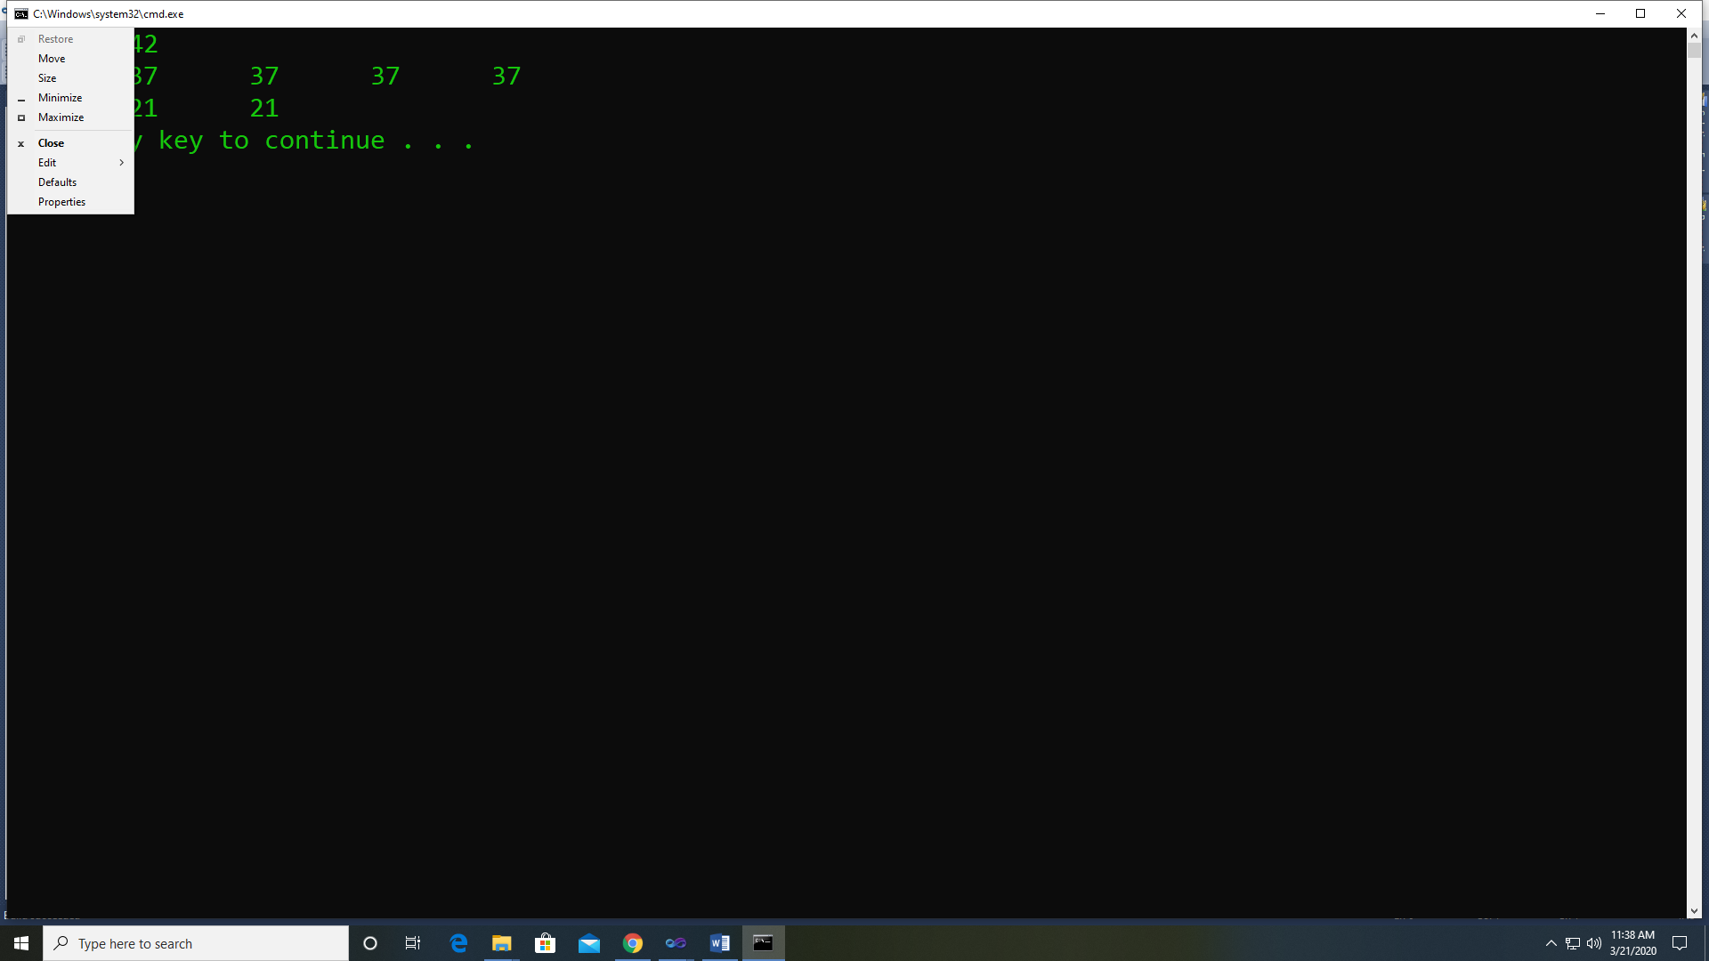

Select Edit and Mark

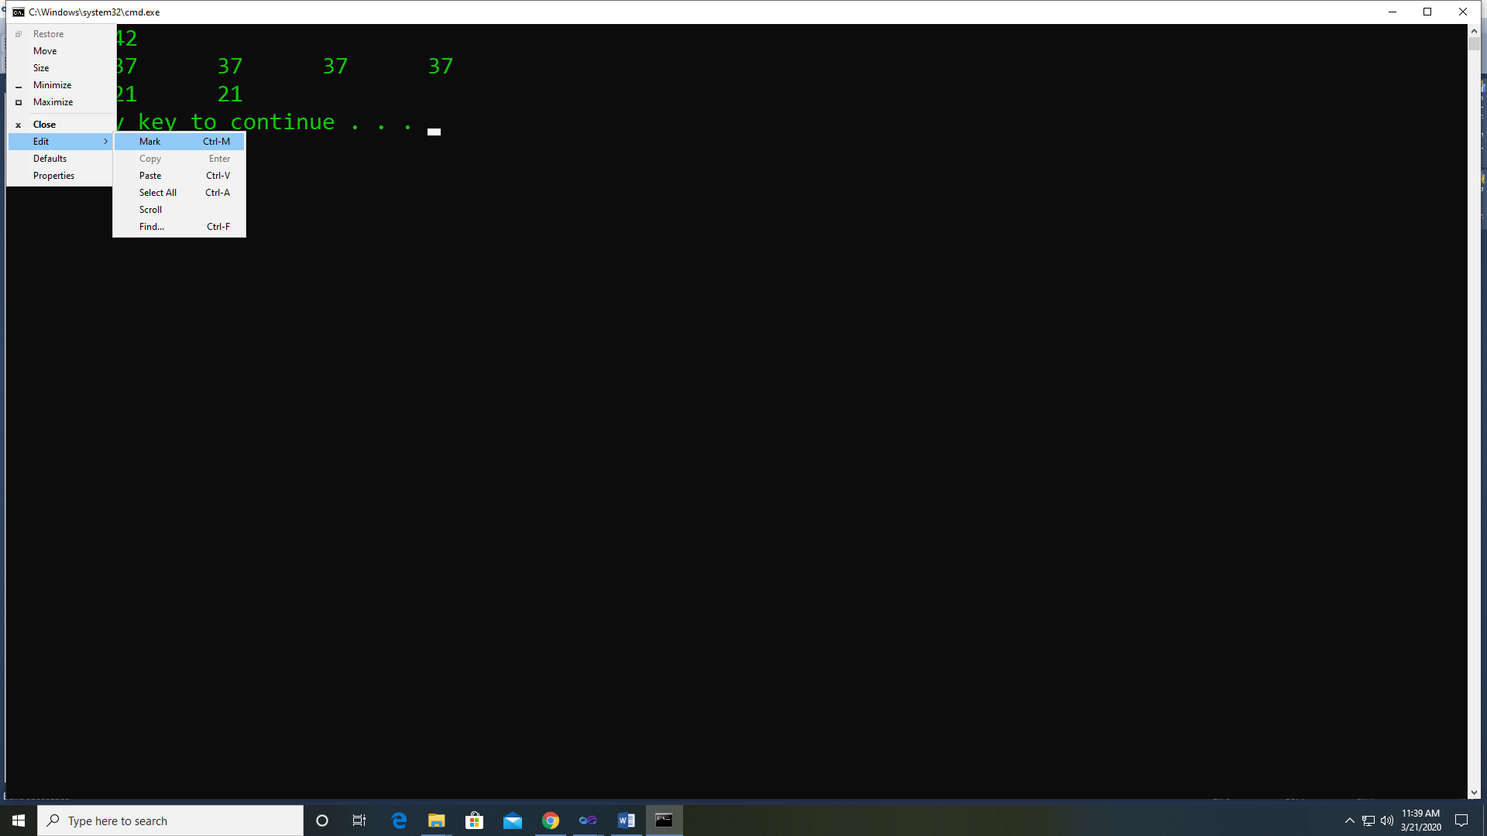

Highlight the area to be captured

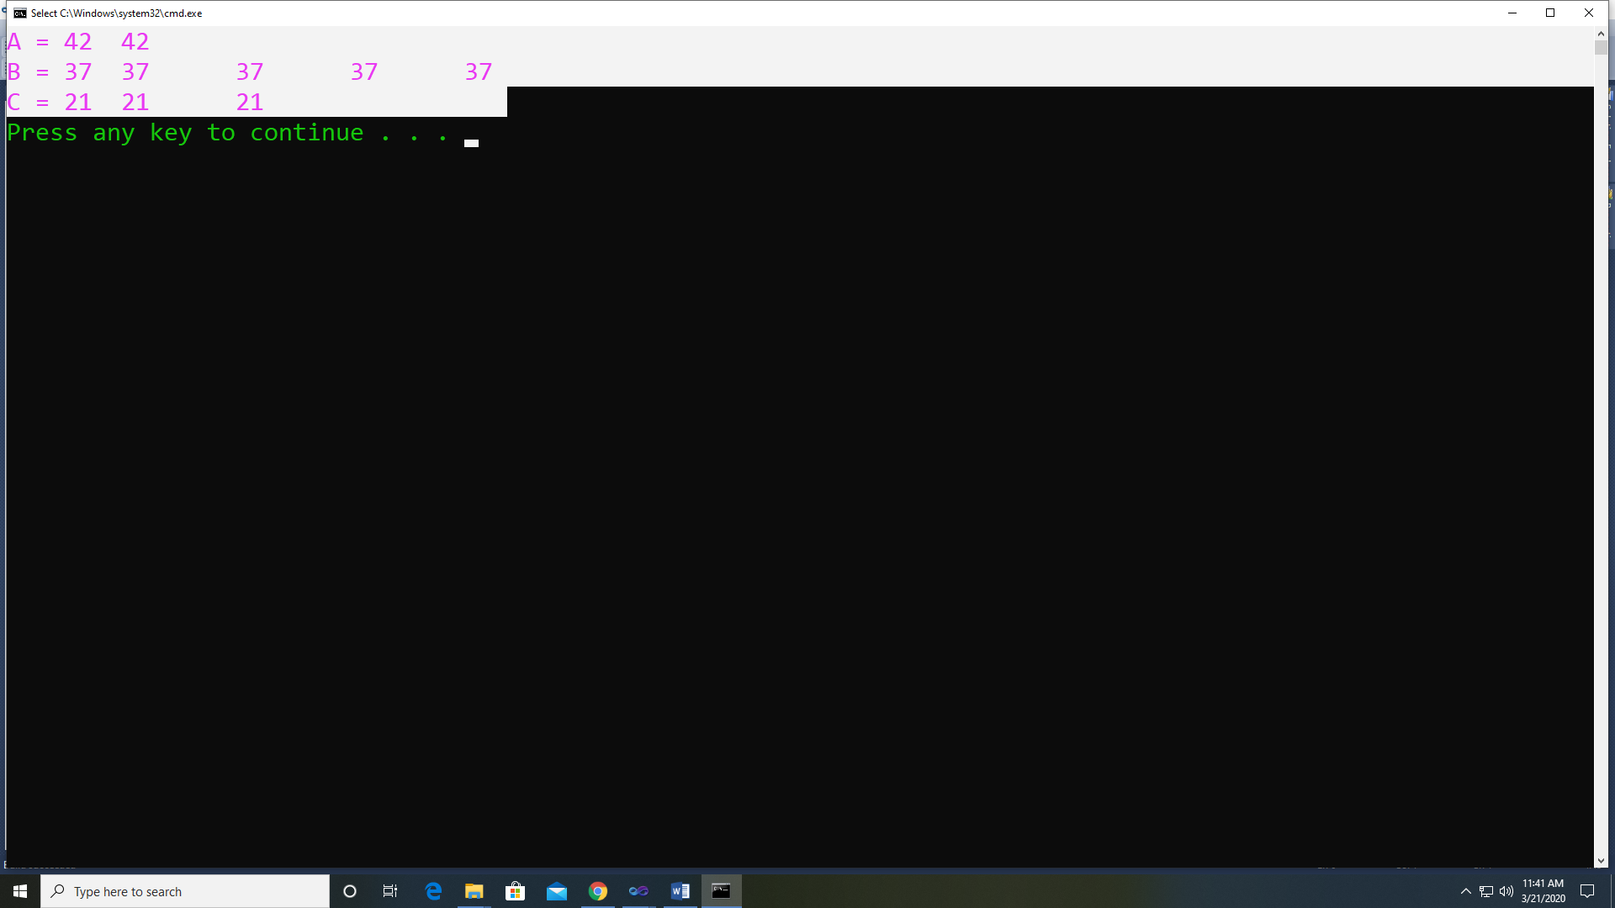

And hit Enter key

This will capture the highlighted area to the windows clipboard.

Open a word processing document.

Hit Ctrl-V key combination to paste the captured area into the word processor (Note: this capture contains editable text.